Simple way to change home directory of Jenkins Server

Recently i came across issue where jenkins server stopped working as the partition on which Jenkins server was installed was full. & since we could not free up any space on the partition as some other applications were installed on it, we decided that we change home directory of jenkins.

## **Change home directory of Jenkins Server**

Firstly locate the current directory for the jenkins server. You can find the location of current Jenkins home directory by logging into the Jenkins page. Once logged in, goto ‘Manage Jenkins’ & select the options ‘Configure System’. Here first thing you will see will be the path to your Jenkins Home Directory.

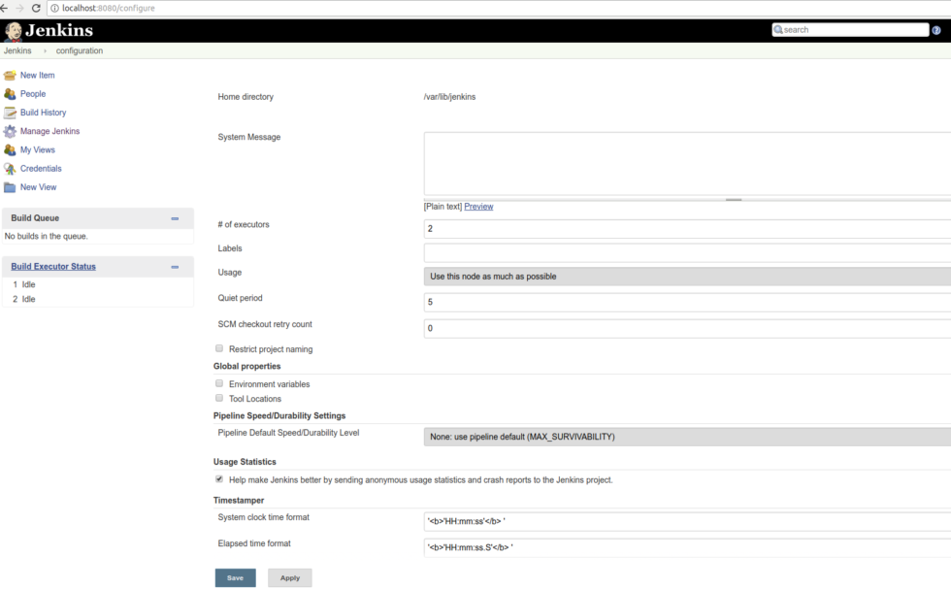  
Now we will create a new folder for the keeping the jenkins. For this tutorial, we will create a new folder in our home directory.

**$ sudo mkdir ~/Jenkins**

Now copy all the content from original Jenkins home to this directory,

**$ cp -rvf /varlib/jenkins/* ~/jenkins**

Once the copy operation has been completed, we will update the environment variable for Jenkins home directory. Environment Variable for jenkins is ‘JENKINS_HOME’, we can update the env varaible with the following command,

**$ export JENKINS_HOME=~/jenkins**

The home directory for the Jenkins has been changed but the updated values for env varaible will only hold for current session. To permanently update the variable, we need to make changed in ‘.bash_profile’ file located in our home directory & make the following entry,

**$ sudo vi ~/.bash_profile**

**export JENKINS_HOME=~/jenkins**

Now last step is to restart the jenkins service to implement the changes,

**$ sudo service jenkins restart**

Now check the updated path again by logging into the jenkins webpage. You shoud now see the updated path for the home directory.